TETRIMINATION

Game Design Document

- Version 0.4

# Contents

Contents

Game Development Team

Overview

High Concept

Unique selling points

Target Platform(s)

Platform Minimal Requirements

Story

Game Objectives

Game rules

Game Structure

Gameplay

Game Controls

Climber

Overlord

Game Camera

HUD

Menus

UI Design

Climber

Metrics

States

Attributes

Movement

Actions

Overlord

Metrics

States

Movement

Actions

Blocks

Art

Setting

Level Design

Example Level Walkthrough

Design Pillars

Audio

Music

Sound Effects

Minimum Viable Product

# Game Development Team

DESIGN

Concept By Baue Olbrechts

Director Stijn Van Coillie

Lead Designer Baue Olbrechts

Designers Andrés Bull

PROGRAMMING

Lead Programmer Erik De Weert

Programmers Baue Olbrechts

Elias Lefebre

Yorick Bongaerts

GRAPHICS

Lead Artist Andrés Bull

3D Modeling Andrés Bull

Elias Lefebre

Graphics/Artwork Baue Olbrechts

Yorick Bongaerts

Additional

Graphics/Artwork Erik De Weert

MUSIC AND SOUND

Music Elias Lefebre

Sound Andrés Bull

Elias Lefebre

MANAGEMENT

Project Leader Stijn Van Coillie

DISCLAIMER: This document is aimed at our team. Use technical, descriptive language to describe elements of the game in detail.

Please discuss before changing the layout order or way of presentation (excluding different font / header, color, etc.).

# Overview

Title: Tetrimination

Genre: 4-player Couch Party Platformer

Platform: Xbox One (& Windows PC)

Release Date: N/A

Rating: PEGI 16

Publisher: N/A

Target: Mainly friends and family members allowed to play games of PEGI 16.

## High Concept

“Become an overlord and build your medieval tower by squashing those trying to reach you or be a climber risking their life to become the new overlord!”

This game pitches one player against the rest in rounds of fast-paced platformer action where you build the platforms and try to become the longest standing overlord! Use your cunning and quickly drop down the building blocks of your tower to get rid of those pesky climbers or get pushed down to the rank of a climber yourself!

## Unique selling points

As an overlord, you can **build a tower** in a grid-based layout **on the bones of your enemies**. You can use faints, mind games or careful planning to **trick your enemies** and get rid of them. Be careful to not build too high as other tower owners might not be too happy with their new neighbor!

Climbers can **work together** and distract the overlord **or hinder each other** so they themselves can **become the next overlord**. Place down **ladders to climb up high** and reach the overlord but be careful as you only have one. Other players might use you for your ladder or the **overlord** can even **break** **them**! So quickly **pick them back** up but be careful that the overlord doesn’t drop the next piece of his tower on your head!

## Target Platform(s)

Our target platform is mainly Xbox, but the game could be easily ported to all consoles and/or pc.

# Story

The story of the game is that the overlord (a child) wants to play with his friends, but can’t because of COVID-19. Thus, they imagine 3 little knights which he can play with in his toy box. The child is mad however, because he can’t play with his friends, so he throws a tantrum. He flings his blocks around and into the toy box, posing a great danger for the climbers. The climbers try to stop this calamity by going up to it and ‘killing’ it. After winning over the overlord, the knight becomes corrupted by power and becomes an overlord himself. Trying to keep this power, he tries to kill the other climbers in an effort to safeguard himself. This cycle keeps repeating and repeating until the game is over.

# Game Objectives

The objective of the game is to score more points than any other player in the game. The scoring system will be explained in detail in the game rules.

# Game rules

The majority of the game is contained in a grid with a certain size that we, the developers, decided to be 8x12, but we could in theory have the size be a player choice. In this grid 3 out of 4 players will be present as climbers. The last player will be on top of the grid as the overlord. The climbers can score points by surviving and getting to the top of the grid to kill the overlord, while the overlord can increase their score by just being the overlord and also by crushing and imprisoning the climbers. To help their cause, the overlord has the ability to drop blocks in the grid, like a tetris player. The climbers can then use these blocks dropped by the overlord by climbing up them. The climbers die however, when they get crushed by the blocks or when they get imprisoned by the blocks. To help prevent this, the climbers all get 1 reusable ladder which they can use to climb up a 2 block vertical gap.

# Game Structure

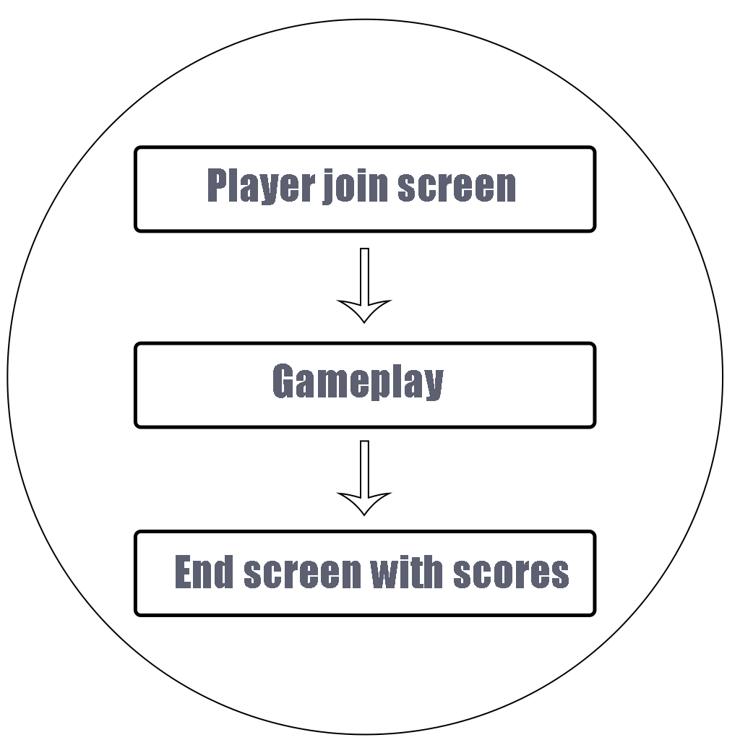

# Gameplay

## Game Controls

### Climber

### 

### Overlord

## Game Camera

During the main gameplay, a static perspective camera that has the entire playfield in view, with a slight angle downwards so the top side of blocks are just barely visible. This gives the field a bit of depth instead of looking like a 2d game. Background “items” like hills or buildings are more washed out to draw attention to the foreground. Screen shake can occur with certain events like a block landing on a hard surface.

This camera view takes up ~3/4th from the left side of the screen. The rest of the screen is taken up by HUD displaying all player portraits with respective scores, the next block for the overlord, currently held ladders, …

## HUD

The HUD will display all player-scores, which player is which kind of character, if a player still has a ladder to deploy and what the next block is that the overlord can drop.

## Menus

There are two menus: the character selection screen and the pause menu. In the pause menu, you are able to change a couple settings, like how loud the game is. In the character selection screen, players will be able to join the game and choose a color for their character.

# UI Design

# 

# Climber

The climbers are little knights in shining armor, coming to defeat the evil overlord and to save the world. They are very strong, so they can jump up to a full block in the air and they can also push the blocks around. They all have a distinct color liking, so they are easy to recognize.

## Metrics

Jump height: 1 block

## States

Alive: The climber can use all of its abilities in their endeavor to kill the overlord

Dead: The climber will commit seppuku when imprisoned or will be violently splattered when crushed

## Attributes

Ladder: each climber has one ladder. This ladder can be placed against block rows with a height of 2 or 3 blocks.

Health

## Movement

A Climber runs around with a speed of 8 units per second. He can jump his own height, i.e. 1 unit.

## Actions

Place ladder: using the X button (or Q) when there is room for a ladder

Pick up ladder: using the X button (or Q) while next to their ladder

Push block: using the B button (or E) while next to a block that is not supporting any other blocks or players, will not be pushed into another block

Kill overlord: using the Y button (or Enter) while on top of the grid and next to the overlord

# Overlord

The overlord is a gigantic, looming and menacing being that threatens the climbers. This character does not move itself but controls a hand that directs where to drop the next building block. After a few seconds, the hand begins to tremble, and the block begins to tremble to signify they cannot hold onto it for much longer before having to forcibly drop it. The overlord can also drop the block before this happens pushing a button. The overlord has a slight delay between being able to drop blocks, but is able to strategize in the meantime by looking at the block he’s going to get next.

## Metrics

N/A

## States

Alive

Dead

## Movement

The overlord is static at the top of the grid, but they can move their hand by using the left joystick (or A/D)

## Actions

Drop block: using the A button (or Space) the overlord can drop a random block

Fast throw: using the B button (or Enter) the overlord can throw a block at an accelerated pace

# Blocks

All blocks function the same, they get dropped by the overlord’s hand and they fall into the grid, when they hit another block or the ground, they stop falling.

The different blocks that are in the game are the following: 1x1, 2x2, 1x1 letter block, 3x1, a 3x2 arch and a 2x2 L shaped block.

# Art

## Setting

The game is set in a toy box so to speak. The climbers are small imaginary soldiers or wizards. They stem from the mind of a child who wants to play with his friends, but can’t because of quarantaine. This child sees himself as the overlord, throwing his blocks into the toybox. Consequently, the style of the characters and blocks will be very toy inspired.

# Level Design

As stated before, the location of the world is inside a toy box, but almost everything that you see isa world created by the mind of the child. This means that we can have a very open world, while staying in the confines of the toy box. The design of the actual walkable level is very minimalistic, because the walkable surface gets built by the overlord while the game is running. The scenery of the level contains a forest, the toy box, the overlord and some blocks scattered around.

## Example Level Walkthrough

Gameplay Round:

At the start of a round, 3 climbers are spawned at the bottom of an empty grid and an overlord at the top. The overlord starts building and the climbers start climbing. The round ends when all climbers are eliminated, the overlord is killed by a climber or the overlord builds out of the designated grid.

When a round is over, the field resets and a (possibly new) overlord is assigned. If, last round, the overlord eliminated all climbers, they remain overlord for another round. Else, if a climber had reached the top layer right under the overlord, they kick down the old overlord and become the new overlord for that round. In case of the overlord building too high, the surviving climber that is currently the highest becomes the new overlord (random in case of a tie).

After all rounds are over and the points are distributed, a victory screen is shown, with a ranking of the players and you can end the game.

# Design Pillars

Pillar #1: Cunning

The overlord can plan a step forward by laying out their tower to their advantage and viewing the next available building block. But on the other side climbers CAN work together by splitting up to divert the attention of the overlord. The ability to influence each other is also made easier by playing locally.

Pillar #2: Take-That!

As said climbers can work together, but also push each other around using the block-pushing mechanic. The game is ultimately won by the player with the most points. These must either be earned yourself or by making sure others don’t get as many as you can get.

Pillar #3: Balancing

Every feature has the ability to easily give an advantage to either side, as such an advantage to the other side, or a disadvantage to that ability must be introduced to keep things fair. As much as skills, cunning and planning are required, gameplay must be balanced.

# Audio

## Music

Character selection screen music

Music that plays during gameplay

## Sound Effects

Climber jumping sfx

Block hitting the ground sfx

# Minimum Viable Product

Our MVP will contain the basic gameplay: four players, 3 climbers and an overlord, playing the game. Next to that, we have a main menu with an options menu, a character selection screen and a high score screen.

Graphics:

* 1 character model for the climbers and 1 for the overlord and block models
* A nice shader to give a cartoony look to the game
* A UI with a middle ages book look

Effects:

* Sound effects when a block lands or a climber jumps.